Q1a



Answer. Mary Smith can take any of these subjects

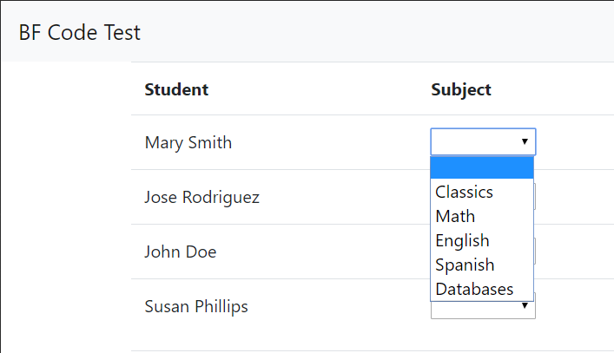

Q1b



Answer. Multiple students can take the Classics subject

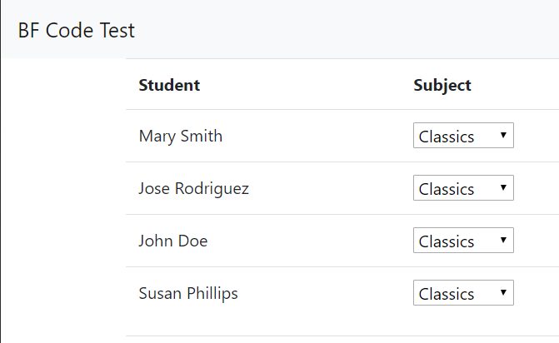

Q2



Answer. Jose Rodriguez can take multiple exams

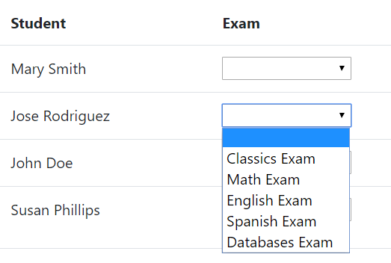

Q3



Answer. I wasn’t able to display the grade. With more time I would’ve come to a solution.

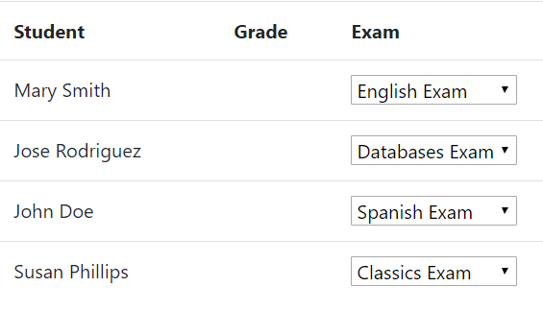

Q4



Answer.

